CREATING A PARENT PORTAL LOGIN
- Access the Parent Portal site
https://ps.wcs.misd.net or wcskids.net (under Parents/Students)
- Click on First-Time Login Directions (English and Arabic directions available)
- Click on Create Account tab, then click on Create Account
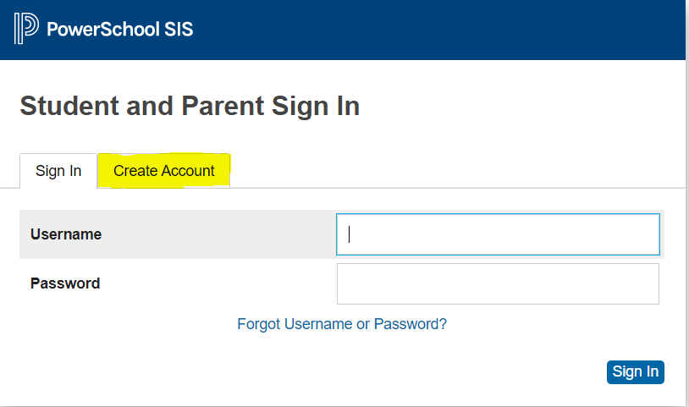
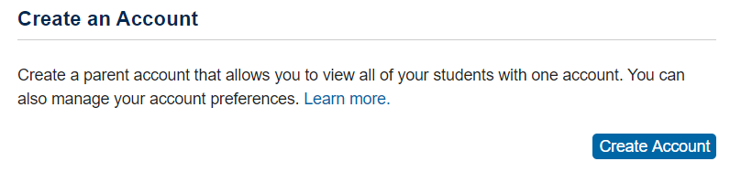
- Fill in the Parent and Student information (example on next page). Hit Submit when you are finished entering student(s) information. You will get the following message.
- Check your email (may appear in junk mail) – message will come from ParentPortal@wcskids.net and may take up to 10 minues to receive. Click on the link to verify your account.
- Sign into your Parent Portal account using the Username/Password used in Step 3.

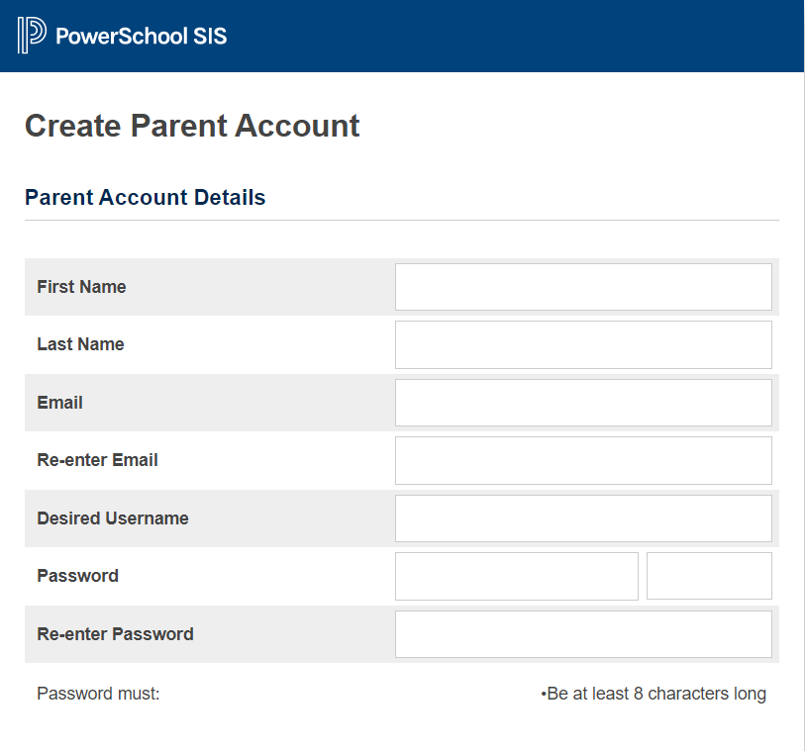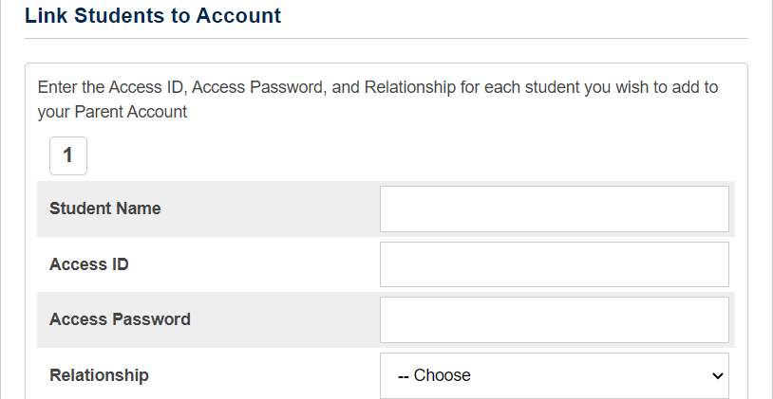
Re-Enter Password
Password – Cannot match student or parent name
Unique Username
Re-enter Parent Email Address

Parent Email Address

Parent Last Name
Parent First Name
MUST USE UPPERCASE LETTERS
Your relationship to the student
Sample: XP2TG3
Sample: P123456
First & Last Name

